|  |
| --- |
| **Department of Computer Science and Engineering** |
| |  |  | | --- | --- | | **Advanced Computer Science Experiment** | | | **assessment form** | | | List of team students | 黄珂邈、童年 | | Project Title | Improved Markov random field for reconstructing super-resolution depth images | | The Stage of Project Inspection | The first project inspection ( ) The second project inspection ( )  The finally project inspection ( ) | | Supervisor Name | 郝祁 | | Inspector Name | 张煜群 |  |  |  |  |  | | --- | --- | --- | --- | | **Components** | **Comments** | **Max.** | **Marks awarded** | | Report content |  | 30 |  | | Report structure |  | 30 |  | | Project management |  | 20 |  | | Communications |  | 20 |  | | **The marks are given and signed by the Supervisor** | | | |   Student Name ： Total Marks out of 100: |
| Student Name ： Total Marks out of 100: |
| Student Name ： Total Marks out of 100: |
| **Assessed by Supervisor:**  (Signature) |
| **The marks are given and signed by the Inspector** |
| Student Name ： Total Marks out of 100: |
| Student Name ： Total Marks out of 100: |
| Student Name ： Total Marks out of 100: |
| **Assessed by** **Inspector:**  (Signature) |
|  |

**Improved Markov random field for reconstructing super-resolution depth images**

**1 Abstract**

Reconstructing accurate 3D environment is a tough work in self-driving. Although Lidar can increase the depth resolution in general, efficient algorithms for depth fusion should be employed for robustness and better recognition and. A novel method is proposed to enhance edge resolution of a single depth image based on optimization of Markov random field formula.

**2 Problems and Objectives**

**2.1 Background**

There is an increasing interest on self-driving all over the world. The method of capturing high resolution depth images is significant for reconstructing 3D environment around self-driving cars. As a useful hardware device, Lidar can provide high resolution depth images in general scenes. However, it costs high price and is still not robust enough to support high level self-driving in practice. Moreover, depth super resolution has been developing. In the field of computer vision, two big ideas are considered for depth super resolution. One is to combine a sequence of depth images and the other is to combine the depth images with the 2D color images of the same scene. Since self-driving has strong real-time requirement, the previous approach is nearly useless in such kind of application. High resolution color images are totally available for self-driving cars so using color images to calibrate depth images is what the studies focus on.

**2.2 Related Work**

About efficient algorithms for 2D-3D fusion, many studies have been done. In the research of Yang et al. [1], joint bilateral filter function is used to guide the reconstruction of depth image. Ferstl et al. have used 2nd order total generalized variation models to put the color information into 2nd regularization items [2]. However, the edge information of 2D images is not well reconstructed in those studies. Jun et al. have proposed the approach of exploring patch self-similarity to realize edge-guided depth super resolution [3]. Liu has contributed to incorporate the window-based data constraints and 2nd order smoothness into the origin Markov Random Field (MRF) [4].

|  |  |
| --- | --- |
| Approaches | Shortages |
| Joint bilateral filter function | Blurring edges |
| Anisotropic total generalized variation | Blurring edges |
| Patch self-similarity for edge guided  (KNN + Inference + JBF up sample) | Huge time complexity |
| MRF with additional constraints | No 2D images segmentation |

Motivated by the studies above, we propose to optimize the algorithm for fusion between low-resolution depth and high-resolution color images based on MRF models to enhance the edge information in depth images.

**2.3 Goals and Objectives**

To prove the effectiveness of our approach, we decide to calculate the root mean square error (RMSE) in different scaling factors with respect to the depth image obtained from the original set of raw images. For comparison, we choose nearest neighbor interpolation and traditional MRF model method. Moreover, we should also control the time cost of processing of each image. The expectation is that the RMSE of our method is lower than the ones using the other two methods and the time cost is not greater.

**3 Design and Methods**

**3.1 System Architecture**

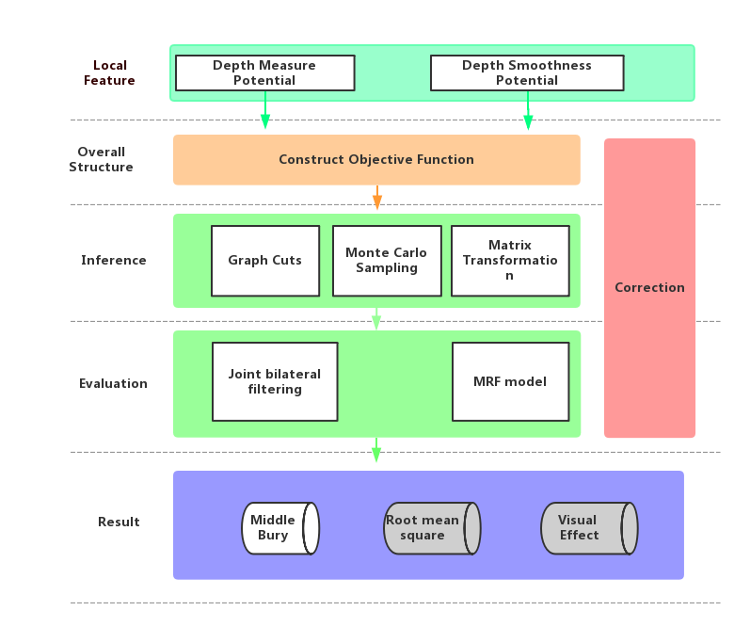

We apply MRF into the problem of generating high-resolution range images. The input to MRF occurs at two layers, through the variables labeled x corresponding to the RGB image pixels, and variables z as the range measurements.

The model can be expressed as four parts:

1. ***The depth measure potential***

 (1)

This potential can measure the distance between the estimated range y and the actual measured range label z.

1. ***The depth smoothness prior potential***

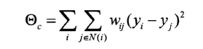(2)

This potential can measure the distance between neighboring nodes, and correspond to the similarity between nodes in RGB map.

1. ***weighting factors between two adjacent image pixels***

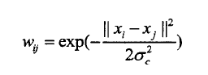(3)

Weighting factor can measure the similarity between the adjacent nodes, and x is the RGB value of each image pixel. This constraint factor determines the smoothness across edges.

1. ***The final objective function***

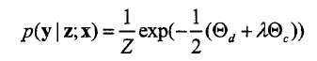 (4)

We defined two constraints potential function, and λdescribes the weighting ratio. In this way, we successfully convert the problem to objective function optimization problem.

**3.2 Procedure**

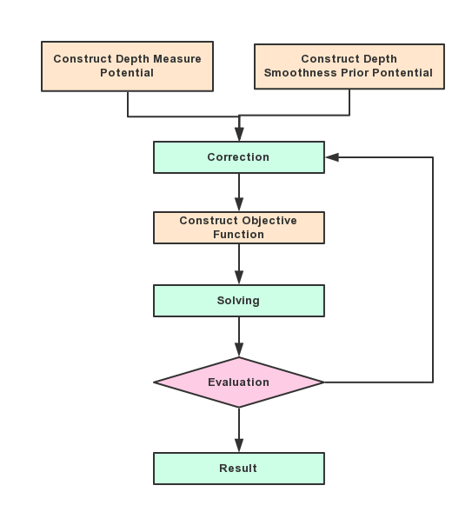

The accomplishment can be divided as three parts. First, construct our model and improve the MRF model. Second, apply our model in the dataset of Middelbury and get the result. Third, compare the result with the actual depth information to correct our model.

1. ***Model Construction***

We concentrate on the local feature and apply our method to improve the potential function. Adjust the weighting factor according to others’ work and then get the final optimization objective function.

1. ***Inference and Application***

Data set Middlebury can help us to test out model. It provides RGB image and depth image from same perspective. Obtain a sparse depth image by sampling from actual depth value, and use it with RGB color image as the inputs. The high-resolution depth image can be restored by our model, and finally, we should compare the result with actual depth image to adjust the weighting factor or other parameters.

1. ***Correction***

With the evaluation to actual depth value and inferring result by other method, we can optimize the potential function to enhance the ability to maintain the feature across object edges.

**4 Expected Result**

Since there are some library-linking problems in the open source datasets, we cannot give an entire initial example result for processed 3D depth images. Here is the sample expected result from others’ research.

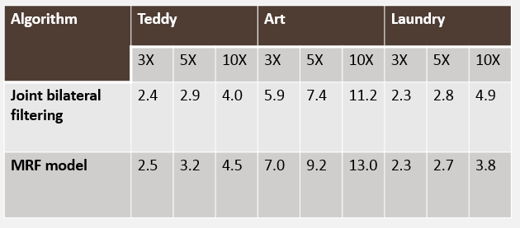

**5 Staffing Plan**

**Algorithm Design**

Nian Tong, as a junior, has joined in the project in Computer Graphic and accomplish some project designs.

In this project, he will mainly design the algorithms, construct the models and improve the models by the evaluation results.

**Model Inference**

Kemiao Huang.

In this project, he is going to accomplish the model inference, apply it to the data set Middlebury and apply basic MRF model and joint bilateral filtering to the same data. The difference between different methods and the actual values helps to adjust and improve our model.

**6 Timeline**

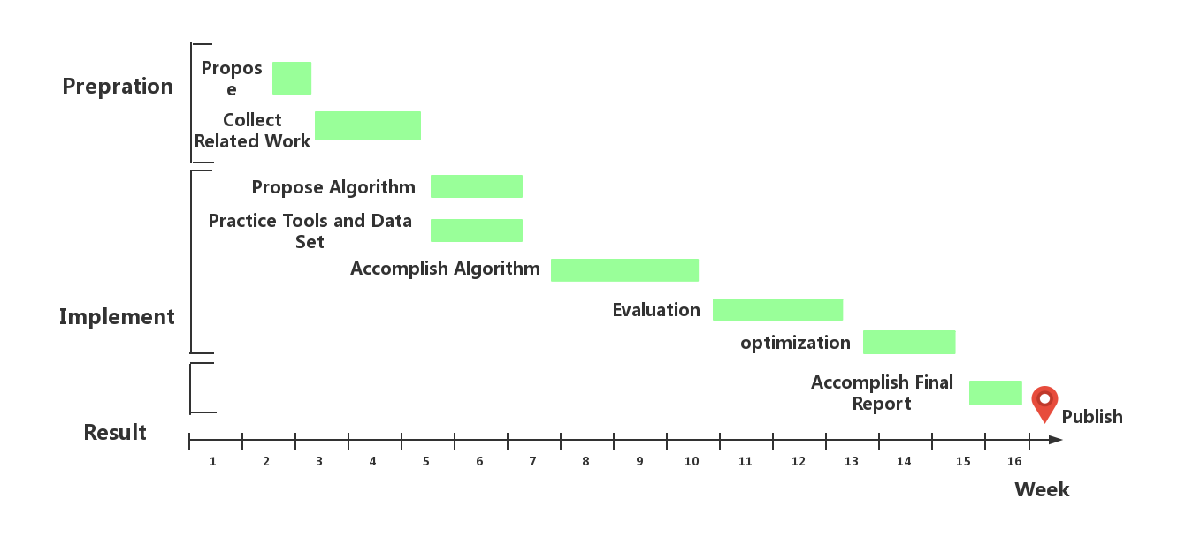

Week 1 to Week 6: Preparation for our work. Collect data and propose our model.

Week 7 to Week 10: Accomplish our model and apply it to data set.

Week 11 to Week 14: Evaluate our result with other methods and actual value, and improve our model.

**Reference**

[1] Q. Yang, R. Yang, J. Davis and D. Nister, "Spatial-Depth Super Resolution for Range Images," 2007 IEEE Conference on Computer Vision and Pattern Recognition, Minneapolis, MN, 2007, pp. 1-8.

[2] D. Ferstl, C. Reinbacher, R. Ranftl, M. Ruether and H. Bischof, "Image Guided Depth Upsampling Using Anisotropic Total Generalized Variation," 2013 IEEE International Conference on Computer Vision, Sydney, NSW, 2013, pp. 993-1000.

[3] J. Xie, R. S. Feris and M. Sun, "Edge guided single depth image super resolution," 2014 IEEE International Conference on Image Processing (ICIP), Paris, 2014, pp. 3773-37777.

[4] J. Liu, “彩色图像引导的深度图像增强,” Zhejiang University, Zhejiang, 2014, TP391.41